Project-1
Stack, Queue and Deque Applications

Your name: Hoang Nguyen

Instructor: Vinayak Elangovan

Submitted On: 09/21/2022

TABLE OF CONTENTS

1 | INTRODUCTION | 1
2 | BACKGROUND (optional) | 1
3 | DESIGN & IMPLEMENTATION | 1
4 | RESULTS / SAMPLE OUTPUTS | 1-2
5 | CONCLUSION | 2
6 | REFERENCES | 2

1

- INTRODUCTION
In this project, I implemented my own class of Tower of Hanoi as well as a solving it using both iterative and recursive processes, as well as some real life example and solution using queue and deque.

- BACKGROUND (optional)
I used python’s sleep function as well as ittertools’ zip_longest in order to slow down and show the process of solving the Tower of Hanoi in a command line interface

- DESIGN & IMPLEMENTATION
For Tower of Hanoi I consult the wikidepia on the problems to get an understanding of the game and create a solution for it.
For recursive solution I uses 4 variable, n for the number of disks, s for rod 1 a.k.a the source where all the disk are originally, a for auxilery a.k.a the middle rod, rod 2, and finally d for rod 3, the destination, the function then recursively lowers n by 1 and calling itself twice, and switch s, d, a on it’s 2nd call.

- RESULTS / SAMPLE OUTPUTS
tower of hanoi:
Starts:
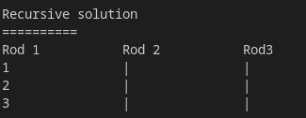
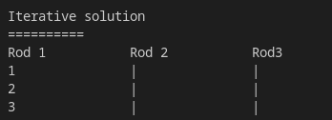
Ends:

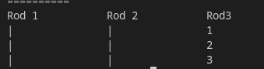
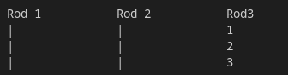

real world situation and using queue to solve:
situation tldr: James is stuck in traffic and this function is used to calculate how much time total does it take for James to get out of traffic.
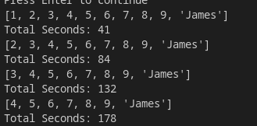

deque application (browser history):
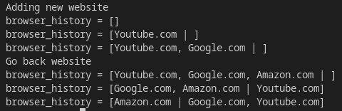

- CONCLUSION
- What have you learnt from this project?
I’ve learn a lot from trying to solve Tower of Hanoi, recursively and iteratively, for example: how to solve Tower of Hanoi iteratively.
As well as implementation of deque, queue, and stacks.

- What ways you can expand this project?
I can expand this project further by creating an actual class for browser history as well as real life situation where I would be using stack instead of queue.

- REFERENCES
https://en.wikipedia.org/wiki/Tower_of_Hanoi

